Dear Parents, Carers and Family Members,

You may already be aware that, this year, BRW is excited to be working with the independent charity National Numeracy on an exciting project which encourages children and families to do maths together. This will initially be rolled out to families of Year 2 and Year 6 children.

In the meantime, there are more ways for all our parents and carers to get involved:

**Tea & Coffee Morning with a National Numeracy Workshop!**

We are pleased to announce the return of BRW Tea and Coffee Mornings! We hope to provide a monthly place for parents and family members to get together, socialise, make friends and support their own and their child’s learning along the way. Our first tea and coffee morning is scheduled for **Wednesday 22nd November 2023, 9.00-10.15 am, in the BRW School Hall**.

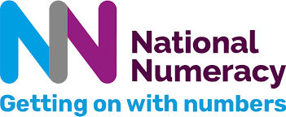In this first tea and coffee morning, we will be hosting a **National Numeracy workshop**, about developing positive attitudes towards maths. We know that maths can sometimes seem daunting but engaging positively with children’s learning can make a big difference to both children’s and parents’ confidence with numbers. **All parents and carers** are invited to attend this unique workshop run by National Numeracy which will be held at the school alongside the tea and coffee morning above on Wednesday 22nd November at 9.00-10.15 am.

The workshop is not a maths lesson, nor does it teach any maths, but is **focused on fostering positive attitudes towards numeracy and tips for ensuring your children develop these too.** This is critical to their success in building strong numeracy skills. The session will cover the importance of maths in the real world, being positive about maths and how to boost your own number skills.

**Please confirm your attendance with the school office in person, via email or over the phone by Friday 17th November.**

Yours sincerely,

Mrs C Hautenne