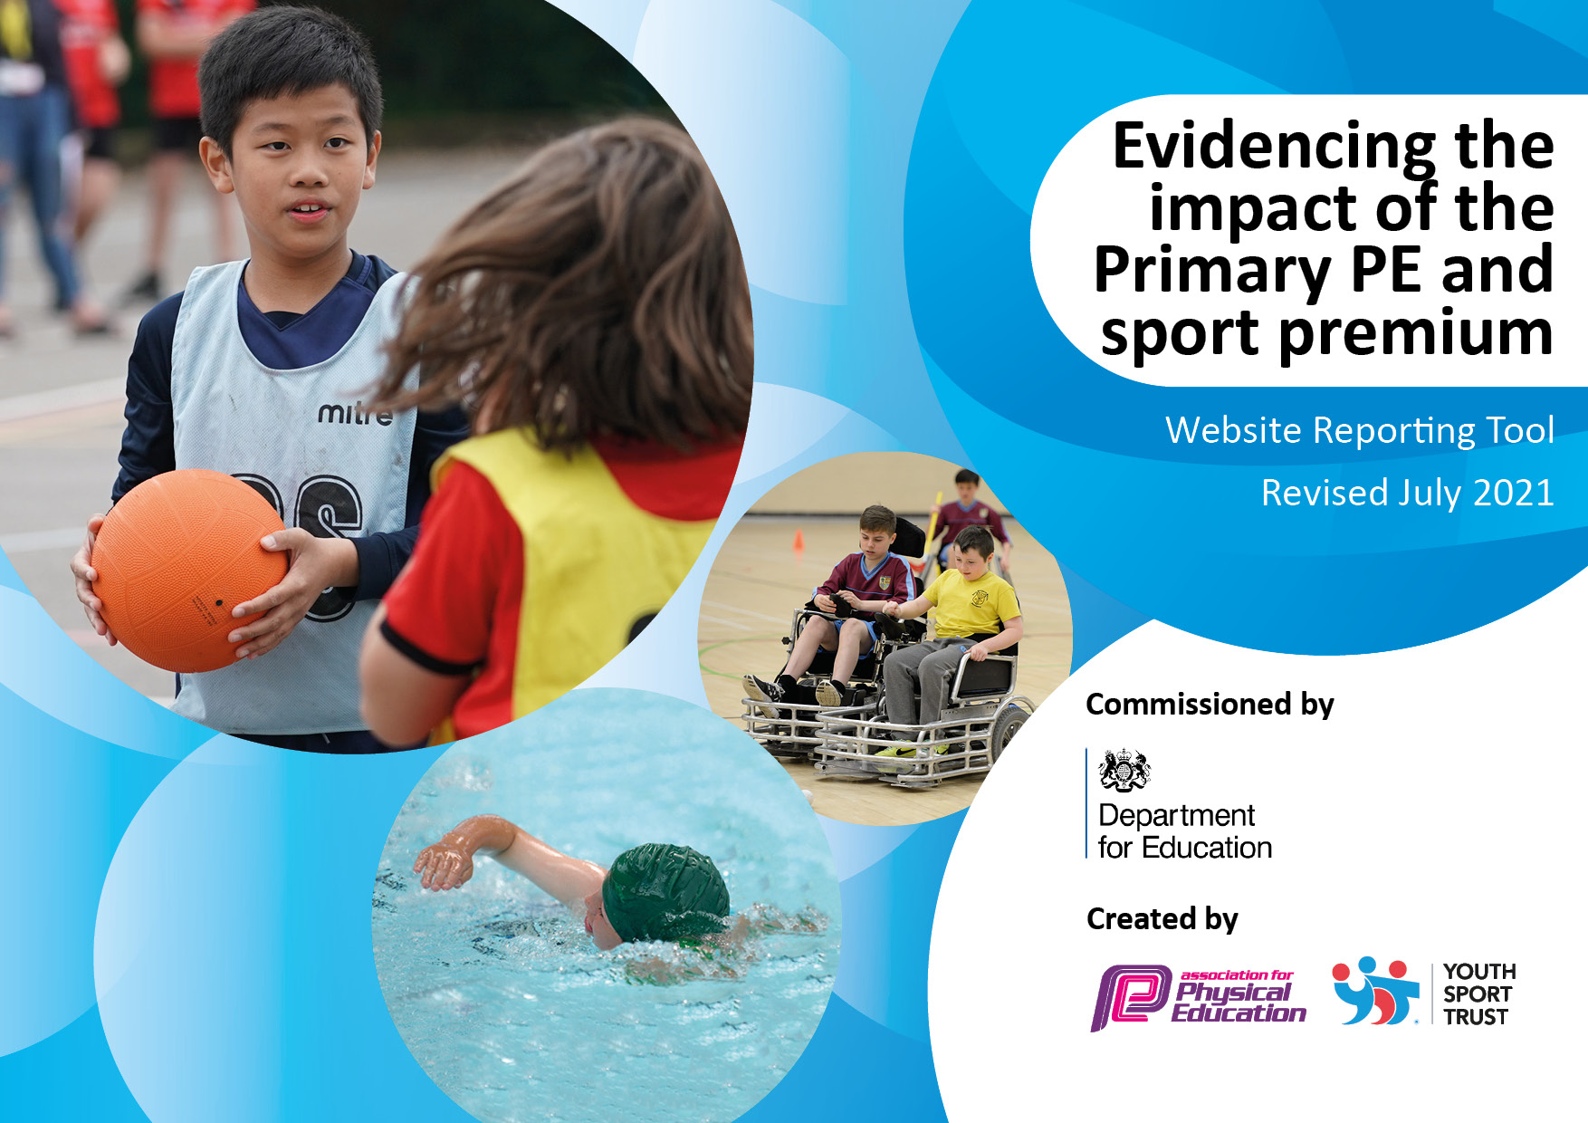

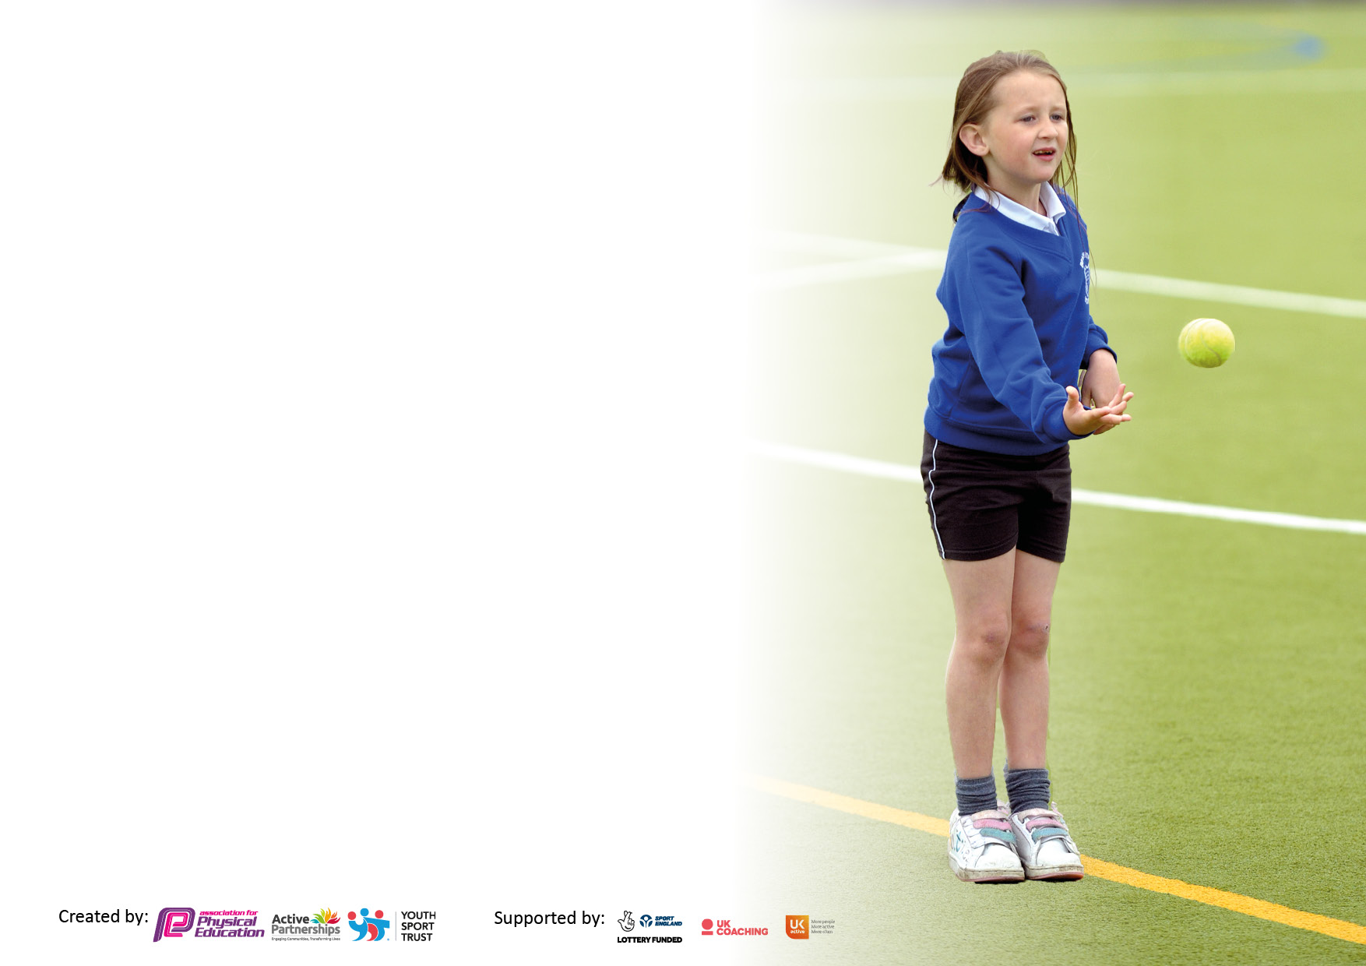

It is important that your grant is used effectively and based on school need. The Education Inspection Framework makes clear there will be a focus on **‘whether leaders and those responsible for governors all understand their respective roles and perform these in a way that enhances the effectiveness of the school’**.

Under the Quality of Education Ofsted inspectors consider:

**Intent** - Curriculum design, coverage and appropriateness

**Implementation** - Curriculum delivery, Teaching (pedagogy) and Assessment

**Impact** - Attainment and progress

To assist schools with common transferable language this template has been developed to utilise the same three headings which should make your plans easily transferable between working documents.

Schools must use the funding to make **additional and sustainable** improvements to the quality of Physical Education, School Sport and Physical Activity (PESSPA) they offer. This means that you should use the Primary PE and sport premium to:

* Develop or add to the PESSPA activities that your school already offer
* Build capacity and capability within the school to ensure that improvements made now will benefit pupils joining the school in future years
* The Primary PE and sport premium should not be used to fund capital spend projects; the school’s budget should fund these.

Pleasevisitgov.ukfortherevisedDfEguidanceincludingthe5keyindicatorsacrosswhichschoolsshoulddemonstrate animprovement.Thisdocumentwillhelpyoutoreviewyourprovisionandtoreportyourspend.DfEencouragesschools to use this template as an effective way of meeting the reporting requirements of the Primary PE and sport premium.

We recommend you start by reflecting on the impact of current provision and reviewing the previous spend.

Schools are required to publish details of how they spend this funding, including any under-spend from 2019/2020, as well as on the impact it has on pupils’ PE and sport participation and attainment. **All funding must be spent by 31st July 2022.**

We recommend regularly updating the table and publishing it on your website throughout the year. This evidences your ongoing self-evaluation of how you are using the funding to secure maximum, sustainable impact. Final copy must be posted on your website by the end of the academic year and no later than the 31st July 2021. To see an example of how to complete the table please click HERE.

Created by: Supported by:

**Details with regard to funding**

Please complete the table below.

|  |  |
| --- | --- |
| Total amount allocated for 2022/23 | £18,160 |
| Total amount allocated for 2022/23 | £18,160 |
| Total amount of funding for 2022/23. To be spent and reported on by 31st July 2023 | £18,160 Total Spent: £13,864 |

**Swimming Data**

Please report on your Swimming Data below.

|  |  |
| --- | --- |
| Meeting national curriculum requirements for swimming and water safety.  N.B. Complete this section to your best ability. For example you might have practised safe self-rescue techniques on dry land which you can then transfer to the pool when school swimming restarts.  **Due to exceptional circumstances priority should be given to ensuring that pupils can perform safe self rescue even if they do not fully meet the first two requirements of the NC programme of study** |  |
| What percentage of your current Year 6 cohort swim competently, confidently and proficiently over a distance of at least 25 metres?  **N.B.** Even though your pupils may swim in another year please report on their attainment on leaving primary school at the end of the summer term 2020.  Please see note above | 59% |
| What percentage of your current Year 6 cohort use a range of strokes effectively [for example, front crawl, backstroke and breaststroke]?  Please see note above | 40% |
| **What percentage of your current Year 6 cohort perform safe self-rescue in different water-based situations?** | 40% |
| Schools can choose to use the Primary PE and sport premium to provide additional provision for swimming but this must be for activity **over and above** the national curriculum requirements. Have you used it in this way? | Yes/No |

**Action Plan and Budget Tracking**

Capture your intended annual spend against the 5 key indicators. Clarify the success criteria and evidence of impact that you intend to measure to evaluate for pupils today and for the future.

|  |  |  |  |  |
| --- | --- | --- | --- | --- |
| **Academic Year:** 2022/23 | **Total fund allocated:** £18160 | **Date Updated:** July 2023 | |  |
| **Key indicator 1:** The engagement of all pupils in regular physical activity – Chief Medical Officers guidelines recommend that primary school pupils undertake at least 30 minutes of physical activity a day in school | | | | Percentage of total allocation: |
| 6% |
| **Intent** | **Implementation** | | **Impact** |  |
| **Your school focus should be clear what you want the pupils to know and be able to do and about what they need to learn and to consolidate through practice:** | **Make sure your actions to achieve are linked to your intentions:** | **Funding allocated:** | **Evidence of impact: what do pupils now know and what can they now do? What has changed?:** | **Sustainability and suggested next steps:** |
| Promote active ways to travel to school through the use of the Living Streets scheme. Children will be rewarded for travelling to school in an active way. | Sign up to the Living Streets scheme – Hailey Andrew. | Free | Living Streets Walk to School scheme has been really successful and it’s motivated the children to come to school in a healthier and more eco-friendly way. | Continue to use the Living Streets scheme to promote active and eco-friendly ways in which pupils come to school. |
| Development of school playgrounds/outside areas in order to **provide outdoor environment which promotes positive, physical play**. | PE coordinator to research and purchase new equipment for playground boxes and equipment. | £920 | Techer and pupil voice questionnaires to be used to gage perspectives and interests on different activities and equipment. | Following teacher and pupil voice, more play equipment was purchased for playground boxes.  Boxes to be replenished termly.  Audit boxes at the end of the summer 23 term. New equipment to be ordered for the next academic year. |
| **Key indicator 2:** The profile of PESSPA being raised across the school as a tool for whole school improvement | | | | Percentage of total allocation: |
| 8% |
| **Intent** | **Implementation** | | **Impact** |  |
| **Your school focus should be clear what you want the pupils to know and be able to do and about**  **what they need to learn and to**  **consolidate through practice:** | **Make sure your actions to achieve are linked to your intentions:** | **Funding allocated:** | **Evidence of impact: what do pupils now know and what can they now do? What has changed?:** | **Sustainability and suggested next steps:** |
| Provide further opportunities for children to engage in enrichment activities i.e. residential, PE kits outdoor adventures and enrichment sports. | PP children and SEND to be given priority for all after school sports clubs and coaching. This will be provided free of charge for PP. | £220 to support PP with payments for residential and after school clubs | Use of school twitter and blog account to promote after school clubs  Pupil and parent voice surveys. Parents felt clubs were advertised well.  Children liked the range of clubs available to them. They would like additional club next year  Informal drop-ins of after-school clubs | Pupil and parent voice surveys used to gage interests for sports and extra-curricular clubs  Focus group identified to develop participation (KS1). All KS groups to be offered different clubs on a rotation basis for the academic year 23-24  End of year/termly data:  **Data:**  **Autumn 2022**  Street Dance -25 (5PP 4 SEN)  Brick for Kids -8 (1PP 1 SEN)  Magical Maths - 12 (2PP)  **Spring 2023**  Basketball – 8 (3PP 2SEN)  Magical Maths – (1PP 2 SEN)  Street Dance – (5PP 7 SEN)  Code Club – (3PP 2SEN)  Football – 18 (6PP 2 SEN)  **Summer2023**  Dodgeball – 18 (2 SEND and 3 PP)  Dance – 24 (6 SEND and 5 PP) |
| Provide opportunities for children to develop gross-motor skills from an early Age (EYFS). Research and purchase resources to support children’s physical development  Bike ability –research and organise bike ability to come into school to deliver road safety sessions with UKS2 | PE Coordinator to research resources to support physical development of younger children.  Possible Bikeabilty sessions for FS2 and younger year 1 children - focus on balance bikes | £466  FREE | End of Year data (ELG)  Staff and pupil voice | 28/30 - 93% achieved Gross motor skills ELG  26/30 -87% achieved Fine Motor Skills ELG  The Bikeability scheme never happened due to poor correspondence from them  PE coordinator to research a different provider for next year |
| SEND enrichment swimming sessions. | Provide opportunity for enrichment swimming sessions for SEND children to attend. | £0 | We were successful in bidding for additional free swimming sessions for the entire Spring term. This allowed for 3 high profile SEND pupils to attend swimming sessions for 12 weeks, All 3 pupils had 1:1 support from their key staff.  Staff and parent voice demonstrated that children grew in confidence when swimming over the 12 weeks.  More children have signed up to after school swimming sessions  8/30 pupils can now swim 25m | SEND pupils have taken part in swimming sessions when their year group has attended and also throughout the year. Attending weekly swimming lessons throughout the school year  PE Coordinator to liaise with Clifton Swimming to continue SEND swimming provision into next year |
| BRW Swimming Gala: **Raise the profile of swimming across the school. Increase the number of children (including SEND) to represent their school house and take part in swimming races. Increase in self-esteem and transferable skills** | Planned assemblies to raise profile of sport i.e. Water Safety in Autumn Term  Swimming Gala to take place in the Summer Term | Free | End of year/termly data  Records of performance in annual swimming galas  Pupil voice contribution | The swimming Gala hasn’t happened due to health and safety issues regarding spectators. Year 6 pupils were instead given an additional swimming session in the summer term.  PE coordinator to liaise with School Swimming Nottingham about how to do this moving forward into next year. |

|  |  |  |  |  |
| --- | --- | --- | --- | --- |
| **Key indicator 3:** Increased confidence, knowledge and skills of all staff in teaching PE and sport | | | | Percentage of total allocation: |
| 45% |
| **Intent** | **Implementation** | | **Impact** |  |
| Your school focus should be clear | Make sure your actions to | Funding | Evidence of impact: what do | Sustainability and suggested |
| what you want the pupils to know | achieve are linked to your | allocated: | pupils now know and what | next steps: |
| and be able to do and about | intentions: |  | can they now do? What has |  |
| what they need to learn and to |  |  | changed?: |  |
| consolidate through practice: |  |  |  |  |
| CPD  Multi Sports coach to support the training of Class Teachers and Teaching Assistants in multi sports and skills in order to ensure staff are confident in teaching multi skills in the long term.  All class teachers to take part in 2 half term sessions of mentoring with GF. Each of the CPD sessions will have a different focus whilst embedding the targets worked on in the first session.  Class teachers to blog about their PE sessions to celebrate success and raise the profile of sport at BRW. | PE coordinator to make contact with coaches in relevant areas  PE coordinator to schedule focus areas for coaches/teaching staff  PE coordinator to plan opportunities to showcase children’s work and audit impact | £3550 | Teacher voice surveys  Pupil voice surveys – conducted annually  Learning walks/informal lesson observations  Use of school blog to promote and celebrate class PE Enrichment activities/successes | Staff CPD has been given to all year groups in school with GF. Following staff feedback this has been incredibly valuable.  GF also uses the Get Set 4 PE planning to enhance his sessions.  Following pupil voice, pupils enjoy taking part in PE sessions with GF. Learning walks also highlight that children are working to develop their skills  GF with continue to support CPD for all new staff next academic year |
| Dance coach to support the training of Class Teachers and Teaching Assistants in pedagogy of Dance in order to ensure staff are confident in the pedagogy of teaching dance in the long term.  Dance coach to also support CPD for Gymnastics across all year groups within school. CPD for all staff to ensure confidence when teaching gymnastics in the long terms | PE coordinator to plan opportunities to showcase children’s work and audit impact | £3780 | Teacher voice surveys  Pupil voice surveys – conducted annually  Learning walks/informal lesson observations  Inter-school dance showcase (termly). School blog and website used to promote this | All staff have received at least half a term of CPD with BB for both Dance and gymnastics  BB is using Get Set 4 PE planning for all year groups to ensure objectives are being met by all.  Assessment linked to these objectives is carried out by teachers.  Learning walks and Staff and pupil voice highlight quality CPD and learning is taking pale  BB with continue to support CPD for all staff next academic year |
| Subscribe to Get Set 4 PE scheme of work for the whole school – FS-KS2. This scheme will allow consistency, high quality lesson planning and ensure progression of skills through all year groups. | PE coordinator to produce a progression of skills document to show the coverage throughout the whole school.  Monitor planning to ensure that the scheme is being used and implemented throughout all year groups.  Staff Voice questionnaire to find out if the scheme has been useful, has it helped with planning and delivery? Has staff confidence increased?  Lesson drop ins to see how the scheme is being implemented and to listen to pupil voice on the quality/enjoyment of their lessons. | £560 | Teacher voice surveys  Lesson drop-ins  Pupil voice surveys  Planning scrutiny/mind-maps | Get Set 4 PE is used successfully throughout school. Subscription to be renewed for the next academic year  Learning walks demonstrated that the scheme is being implemented well across all year groups.  School PE overview and objectives has been produced for staff to allow for a clear coverage across school.  Staff voice demonstrates that Get Set 4 PE is a well used and a liked scheme by all staff. They like how it is set out with ‘make it easier,’ and ‘challenges,’ within each session, and that it is easy to access and use.  Pupil voice shows positivity for the session. Children enjoy taking part in the sessions. They like the level of challenge and state that staff are always pushing them ‘to do their best.’  Pupil voice also demonstrated that vocabulary linked to the sessions is embedded and used successfully. |
| Year 6 Sports Leaders to be trained in playground games with Gordon Fearne.  Chn to become experts in playground games and support/organise games for younger children during lunch times. | PE coordinator to organise a timetable of training for Y6 Sports Leaders.  GF to share his knowledge and skills with SL during training sessions.  PE coordinator to arrange training for YR6 ambassadors | £40 + £300Transport costs | Pupil voice survey  Learning walks – seeing the children in action | Sports Leaders have weekly training with GF. They share that they are learning new activities all the time to use with the younger children.  Sports Leader shave also had training at Harvey Haddon Centre. Pupil voice demonstrated that they found this training valuable and have put into practise what they learned,  Leaders to be trained next year. The will be sent on training at Harvey Haddon as part of the Nottingham City School initiative |
| **Key indicator 4:** Broader experience of a range of sports and activities offered to all pupils | | | | Percentage of total allocation: |
| 24% |
| **Intent** | **Implementation** | | **Impact** |  |
| **Your school focus should be clear** | **Make sure your actions to** | **Funding** | **Evidence of impact: what do** | **Sustainability and suggested** |
| **what you want the pupils to know** | **achieve are linked to your** | **allocated:** | **pupils now know and what** | **next steps:** |
| **and be able to do and about** | **intentions:** |  | **can they now do? What has** |  |
| **what they need to learn and to** |  |  | **changed?:** |  |
| **consolidate through practice:** |  |  |  |  |
| Enrichment swimming at KS1 **to ensure that children are engaging in physical activity from their first years in primary school. To develop skills in independence, balance and coordination which will can be used in other areas of PE and Sport in the future.** | PE coordinator to coordinate schedule and liaise with leisure centre to provide coaching  PE coordinator to review coaching schedules/timetables and focus areas for teachers over course of the academic year  PE coordinator to collate termly data on pupil progress | £2574 | End of year/termly data  Records of performance in annual swimming galas  Pupil voice contribution | KS1 Swimming currently taking place this term.  Informal feedback so far from staff and pupils has been positive. Data to follow later in the term |
| After school clubs to be provided:  Basketball  Football  Dance  Gymnastics  Cricket  Yoga  Drum Fit | PE coordinator to coordinate coaches and timetables to ensure a range of clubs are on offer all year round to a range of pupils.  PE coordinator to ensure that children are able to attend at least one club (priority given to children who haven’t attended a club already)  PP/SEND children given priority and funding to attending a club.  PE coordinator to research coaches/apprentices to run lunch/after school costs | Drum fit – subscription renewal  7x monthly payments £100.56 = £703.92 | Drum fit subscription renewed for the next 12 months.  EYFS children have benefitted greatly from it – developing core (fine and gross motor skills)  Year 1 pupils are also benefitting from using this as a weekly intervention.  Pupil and Staff voice show the positive impacts of using it | Increased participation for children across all age-groups throughout school.  Increasing numbers of SEND/PP children attending clubs  Continue to utilise staff skills to promote after school clubs  PE coordinator to research additional extra curricular clubs to offer to children across school |
| Year 5 and 6 to attend Trent Bridge Classroom.  Year 1-4 Cricket Enrichment Day (Summer 2 term) | PE Coordinator to liaise with Nottinghamshire County Cricket to book event and liaise with Year5/6 staff.  Arrange transport for both classes  PE co-ordinator to liaise with Cricket team and coaches to encourage participation in the game | £250 per class +transport costs  £500  FREE | Pupil and staff voice  Staff CPD – staff stated that the CPD they received has given them some additional ideas for teaching cricket next year and will be using them.  Staff have asked for the trip/CPD sessions to happen again next year as it was really beneficial for them | Increased participation of cricket.  Cricket profile to be raised in the next academic year - now included in the Cycle A and B PE overview.  Positive responses form children and adults. Some children are looking into joining the local Cricket All stars club – parent voice |

|  |  |  |  |  |
| --- | --- | --- | --- | --- |
| **Key indicator 5:** Increased participation in competitive sport | | | | Percentage of total allocation: |
| 0% |
| **Intent** | **Implementation** | | **Impact** |  |
| Your school focus should be clear | Make sure your actions to | Funding | Evidence of impact: what do | Sustainability and suggested |
| what you want the pupils to know | achieve are linked to your | allocated: | pupils now know and what | next steps: |
| and be able to do and about | intentions: |  | can they now do? What has |  |
| what they need to learn and to |  |  | changed?: |  |
| consolidate through practice: |  |  |  |  |
| All year groups to participate in at least one festival  Participation in school events across the county through Nottingham City Schools | PE Coordinator to Liaise with Nick Robb regarding festivals and competitions  PE Coordinator to share competition and festival timetable. Allocate festivals to each year group. | £20 per event +transport   * Did not happen this year | Pupil voice surveys  Details of competitions/events recorded on termly basis with class data | Festivals did not happen this year due to staff being unable to attend events due to timetabling and cover |
| . PE Co-ordinator to have a meeting with Chris Ballard (School Sport Partnership across Rushcliffe) | Discuss PE/festival participation for the next academic year.  Look at provision and support available to PE Co-ordinator | FREE | Meeting held with Chris during the Spring term.  Moving forwards, school will buy into this program of events for the next academic year (cost approx. £750) | Liaise with colleagues regarding pupil participation for the next academic year for afterschool events |

|  |  |
| --- | --- |
| Signed off by | |
| Head Teacher: |  |
| Date: |  |
| Subject Leader: |  |
| Date: |  |
| Governor: |  |
| Date: |  |